Приложение

Описание местоположения границ публичного сервитута

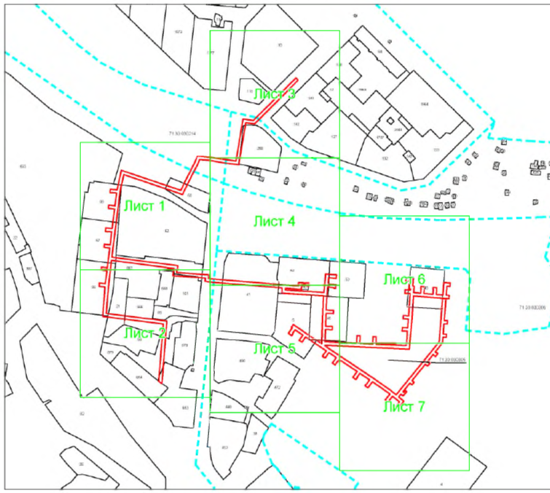
Масштаб 1:3805

Выносной лист № 1

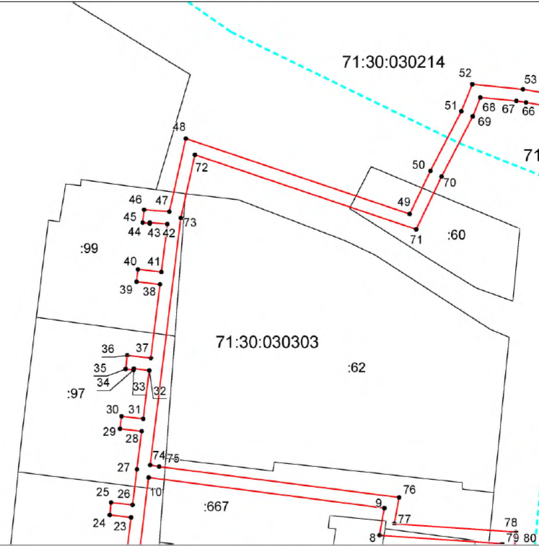

Масштаб 1:1000

Выносной лист № 2

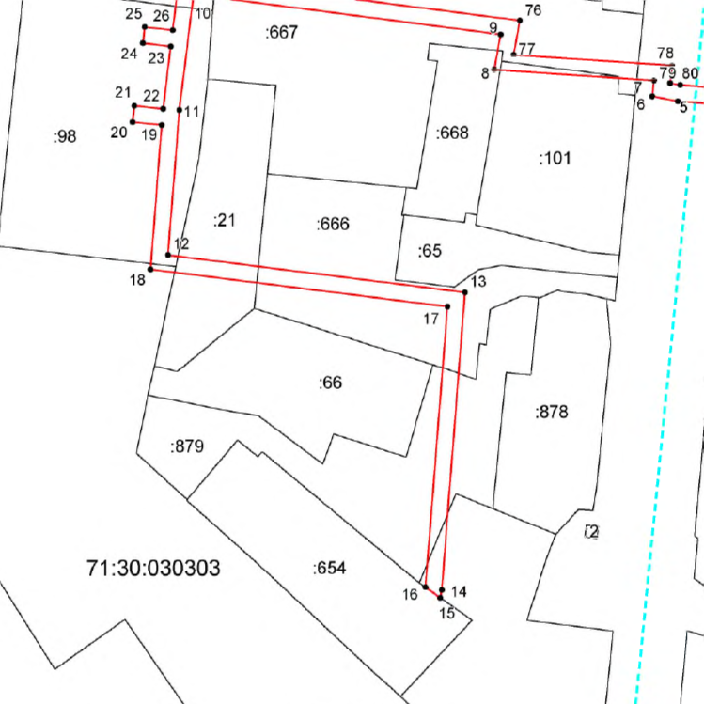

Масштаб 1:1000

Выносной лист № 3

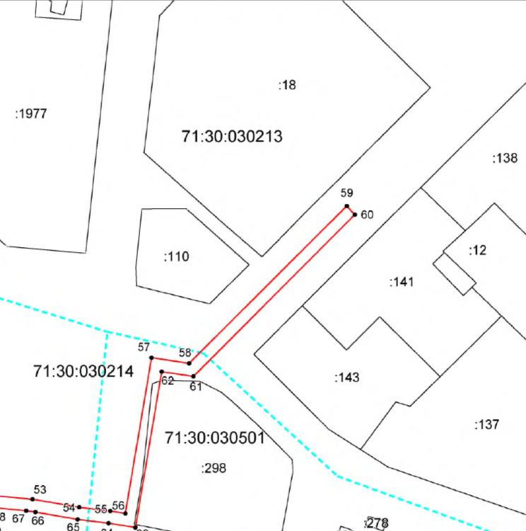

Масштаб 1:1000

Выносной лист № 4

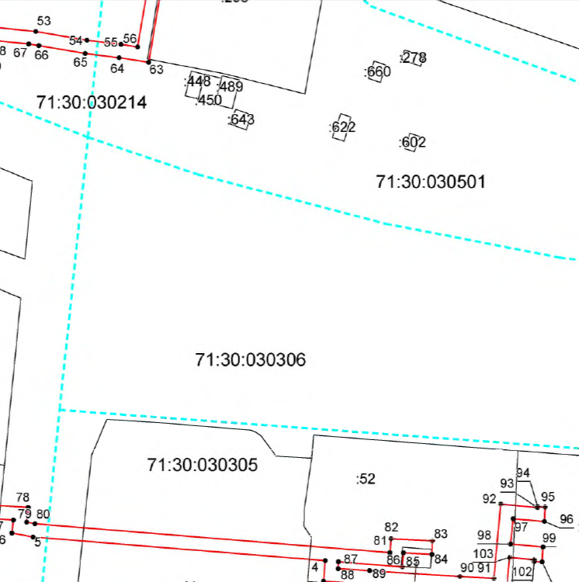

Масштаб 1:1000

Выносной лист № 5
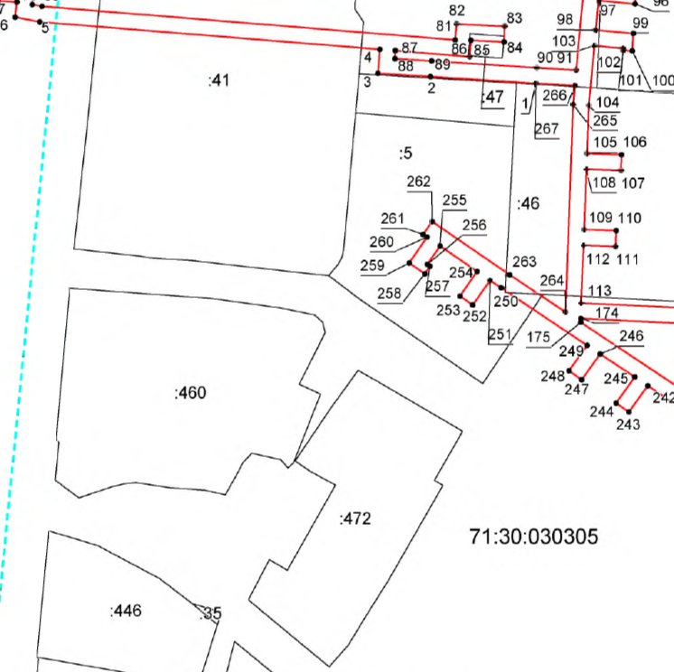

Масштаб 1:1000

Выносной лист № 6

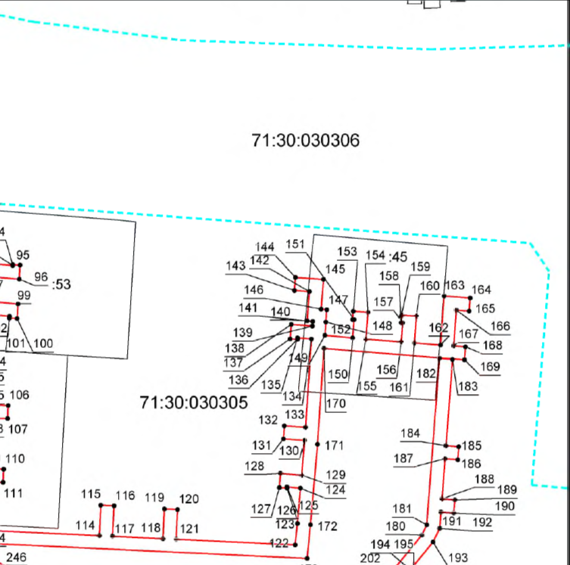

Масштаб 1:1000

Выносной лист № 7

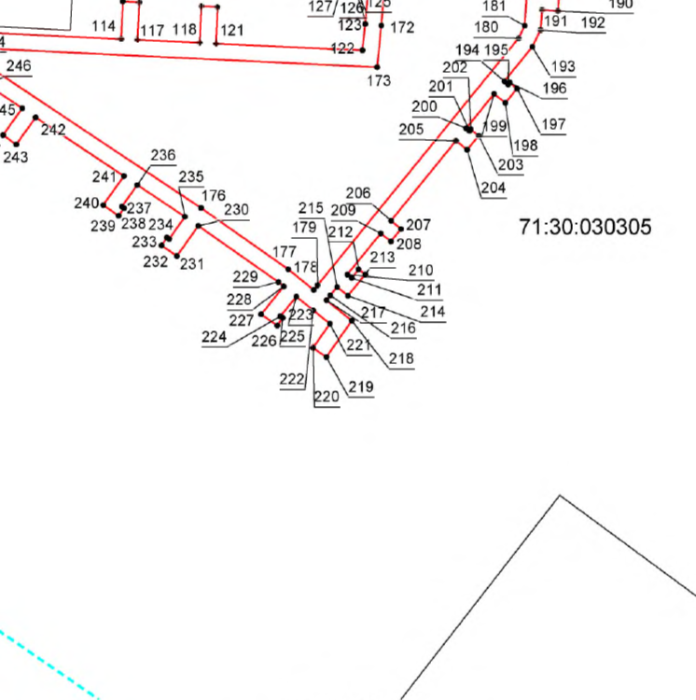

Масштаб 1:1000

Ведомость координат поворотных точек

@ 134439
Обозначение характерных точек границ | Координаты. м
Обозначение характерных точек границ | X | Y
1 | 742200.90 | 268365.92
2 | 742202.64 | 268339.13
3 | 742203.48 | 268325.78
4 | 742209.61 | 268326.22
5 | 742216.65 | 268239.54
6 | 742217.85 | 268233.27
7 | 742221.75 | 268233.68
8 | 742224.41 | 268194.52
9 | 742233.08 | 268196.11
10 | 742242.90 | 268120.83
11 | 742214.47 | 268117.36
12 | 742178.79 | 268114.57
13 | 742169.60 | 268187.34
14 | 742096.44 | 268181.66
15 | 742094.49 | 268181.32
16 | 742097.08 | 268177.69
17 | 742166.11 | 268183.06
18 | 742175.29 | 268110.29
19 | 742210.78 | 268113.06
20 | 742211.53 | 268105.89
21 | 742215.50 | 268106.33
22 | 742214.78 | 268113.37
23 | 742230.12 | 268115.24
24 | 742230.90 | 268108.41
25 | 742234.88 | 268108.87
26 | 742234.09 | 268115.72
27 | 742245.54 | 268117.12
28 | 742257.74 | 268118.63
29 | 742258.54 | 268111.72
30 | 742262.51 | 268112.18
31 | 742261.71 | 268119.12
32 | 742277.21 | 268121.05
33 | 742277.78 | 268116.11
34 | 742277.37 | 268116.06
35 | 742277.66 | 268113.52
36 | 742282.05 | 268114.03
37 | 742281.18 | 268121.54
38 | 742304.78 | 268124.46
39 | 742305.64 | 268116.98
40 | 742309.61 | 268117.44
41 | 742308.74 | 268124.95
42 | 742324.11 | 268126.86
43 | 742324.55 | 268121.23
44 | 742324.29 | 268121.20
45 | 742324.56 | 268118.91
46 | 742328.71 | 268119.40
47 | 742328.08 | 268127.48
48 | 742351.51 | 268132.72
49 | 742327.31 | 268204.17
50 | 742341.12 | 268210.79
51 | 742360.24 | 268220.70
52 | 742368.91 | 268224.16
53 | 742367.29 | 268240.33
54 | 742364.66 | 268255.55
55 | 742363.42 | 268265.67
56 | 742362.64 | 268270.58
57 | 742413.50 | 268279.10
58 | 742411.66 | 268291.34
59 | 742463.06 | 268342.69
60 | 742460.21 | 268345.31
61 | 742407.40 | 268292.74
62 | 742408.96 | 268282.40
63 | 742358.08 | 268273.88
64 | 742359.46 | 268265.11
65 | 742360.69 | 268255.03
66 | 742363.10 | 268241.29
67 | 742363.54 | 268238.26
68 | 742364.65 | 268226.76
69 | 742358.58 | 268224.34
70 | 742339.34 | 268214.37
71 | 742322.39 | 268206.25
72 | 742346.29 | 268135.66
73 | 742326.04 | 268131.12
74 | 742246.88 | 268121.32
75 | 742246.39 | 268124.21
76 | 742236.50 | 268200.81
77 | 742228.09 | 268199.26
78 | 742225.47 | 268238.08
79 | 742221.09 | 268237.63
80 | 742220.61 | 268240.08
81 | 742212.01 | 268345.45
82 | 742216.13 | 268345.78
83 | 742215.55 | 268358.08
84 | 742211.51 | 268357.91
85 | 742211.95 | 268349.46
86 | 742207.75 | 268349.12
87 | 742209.29 | 268330.17
88 | 742207.21 | 268330.09
89 | 742206.63 | 268339.45
90 | 742204.94 | 268366.24
91 | 742204.37 | 268376.32
92 | 742226.47 | 268378.35
93 | 742225.46 | 268389.25
94 | 742225.71 | 268389.27
95 | 742225.58 | 268391.52
96 | 742221.26 | 268391.28
97 | 742222.12 | 268381.97
98 | 742214.57 | 268381.27
99 | 742213.69 | 268390.86
100 | 742209.23 | 268390.62
101 | 742209.35 | 268388.25
102 | 742209.91 | 268388.30
103 | 742210.59 | 268380.91
104 | 742195.29 | 268379.50
105 | 742182.99 | 268379.05
106 | 742182.66 | 268387.87
107 | 742178.67 | 268387.72
108 | 742178.99 | 268378.90
109 | 742163.50 | 268378.36
110 | 742163.20 | 268386.50
111 | 742159.20 | 268386.35
112 | 742159.50 | 268378.18
113 | 742144.71 | 268377.48
114 | 742142.90 | 268415.64
115 | 742152.18 | 268416.08
116 | 742151.99 | 268420.07
117 | 742142.72 | 268419.63
118 | 742141.99 | 268435.00
119 | 742151.03 | 268435.43
120 | 742150.85 | 268439.43
121 | 742141.80 | 268439.00
122 | 742140.08 | 268475.22
123 | 742146.59 | 268475.87
124 | 742157.40 | 268476.82
125 | 742157.76 | 268472.71
126 | 742157.41 | 268472.69
127 | 742157.57 | 268470.41
128 | 742161.95 | 268470.71
129 | 742161.38 | 268477.17
130 | 742172.02 | 268478.09
131 | 742172.45 | 268471.66
132 | 742176.44 | 268471.92
133 | 742176.01 | 268478.35
134 | 742202.98 | 268480.16
135 | 742203.31 | 268475.91
136 | 742202.86 | 268475.88
137 | 742203.02 | 268473.68
138 | 742207.47 | 268474.00
139 | 742206.97 | 268480.47
140 | 742208.35 | 268480.57
141 | 742208.52 | 268478.85
142 | 742217.50 | 268479.54
143 | 742217.82 | 268475.01
144 | 742221.81 | 268475.30
145 | 742221.20 | 268483.84
146 | 742212.10 | 268483.14
147 | 742211.93 | 268484.82
148 | 742208.19 | 268484.57
149 | 742204.12 | 268484.26
150 | 742203.29 | 268492.71
151 | 742208.93 | 268493.16
152 | 742208.96 | 268492.69
153 | 742211.49 | 268492.89
154 | 742211.14 | 268497.35
155 | 742202.95 | 268496.70
156 | 742202.12 | 268507.47
157 | 742207.92 | 268507.93
158 | 742207.96 | 268507.45
159 | 742210.34 | 268507.64
160 | 742210.00 | 268512.09
161 | 742201.80 | 268511.46
162 | 742201.16 | 268519.42
163 | 742216.12 | 268520.55
164 | 742215.52 | 268528.44
165 | 742211.53 | 268528.14
166 | 742211.83 | 268524.24
167 | 742200.89 | 268523.41
168 | 742200.62 | 268527.03
169 | 742196.63 | 268526.72
170 | 742200.15 | 268483.98
171 | 742170.78 | 268482.01
172 | 742146.21 | 268479.85
173 | 742135.90 | 268478.83
174 | 742140.73 | 268377.49
175 | 742139.76 | 268377.45
176 | 742101.05 | 268435.32
177 | 742085.86 | 268456.86
178 | 742080.73 | 268463.19
179 | 742081.92 | 268464.16
180 | 742143.09 | 268513.76
181 | 742146.18 | 268515.25
182 | 742197.07 | 268519.11
183 | 742196.76 | 268523.10
184 | 742170.39 | 268521.10
185 | 742170.10 | 268525.00
186 | 742166.11 | 268524.69
187 | 742166.40 | 268520.80
188 | 742154.11 | 268519.87
189 | 742153.81 | 268523.78
190 | 742149.82 | 268523.48
191 | 742150.11 | 268519.56
192 | 742145.12 | 268519.18
193 | 742140.93 | 268517.16
194 | 742132.41 | 268510.25
195 | 742131.65 | 268511.20
196 | 742132.09 | 268511.56
197 | 742130.59 | 268513.39
198 | 742127.05 | 268510.51
199 | 742129.31 | 268507.73
200 | 742120.80 | 268500.84
201 | 742120.15 | 268501.64
202 | 742120.53 | 268501.95
203 | 742118.94 | 268503.91
204 | 742115.45 | 268501.08
205 | 742117.69 | 268498.33
206 | 742097.88 | 268482.26
207 | 742095.87 | 268484.73
208 | 742092.77 | 268482.21
209 | 742094.77 | 268479.74
210 | 742084.56 | 268471.46
211 | 742083.66 | 268472.56
212 | 742085.84 | 268474.27
213 | 742084.53 | 268475.88
214 | 742079.28 | 268471.63
215 | 742081.46 | 268468.94
216 | 742079.40 | 268467.27
217 | 742078.21 | 268466.30
218 | 742073.12 | 268472.57
219 | 742064.10 | 268466.30
220 | 742066.38 | 268463.01
221 | 742072.35 | 268467.17
222 | 742075.68 | 268463.06
223 | 742079.06 | 268458.90
224 | 742074.22 | 268454.98
225 | 742073.83 | 268455.54
226 | 742071.91 | 268454.21
227 | 742074.67 | 268450.24
228 | 742081.57 | 268455.79
229 | 742082.67 | 268454.44
230 | 742096.60 | 268434.69
231 | 742089.13 | 268429.42
232 | 742091.76 | 268425.62
233 | 742093.71 | 268426.96
234 | 742093.34 | 268427.49
235 | 742098.87 | 268431.39
236 | 742106.75 | 268419.61
237 | 742101.34 | 268415.80
238 | 742100.99 | 268416.34
239 | 742099.09 | 268415.02
240 | 742101.74 | 268411.19
241 | 742108.94 | 268416.33
242 | 742123.51 | 268394.56
243 | 742116.76 | 268389.74
244 | 742119.07 | 268386.47
245 | 742125.73 | 268391.23
246 | 742131.64 | 268382.40
247 | 742125.05 | 268377.71
248 | 742127.37 | 268374.45
249 | 742133.83 | 268379.12
250 | 742148.55 | 268357.13
251 | 742150.49 | 268354.32
252 | 742144.16 | 268349.95
253 | 742146.43 | 268346.66
254 | 742152.76 | 268351.02
255 | 742159.27 | 268341.58
256 | 742154.58 | 268338.34
257 | 742154.11 | 268339.03
258 | 742152.16 | 268337.69
259 | 742154.91 | 268333.71
260 | 742161.54 | 268338.29
261 | 742162.24 | 268337.28
262 | 742165.53 | 268339.55
263 | 742151.86 | 268359.37
264 | 742142.38 | 268373.55
265 | 742195.49 | 268375.50
266 | 742200.32 | 268375.95
267 | 742200.90 | 268366.00
1 | 742200.90 | 268365.92

